# **A description of the problem and background**

Mumbai, formerly Bombay, city, capital of Maharashtra state, southwestern India. It is the country’s financial and commercial centre and its principal port on the Arabian Sea. Mumbai is the capital city of Maharashtra. It is one of the largest metropolitan areas in the world and India’s economic centre. The country's most important seaport, the Jawaharlal Nehru Port, is also located here. It is one of the largest natural ports worldwide and has become one of the most significant transfer sites at the Arabian Sea. The megacity generates more than a quarter of Maharashtra’s gross domestic product. Apart from that, almost half of the Indian foreign trade is transacted here. The economically most significant branches are the finance, cotton, chemical, car and electronics industry.

Mumbai attracts people from all over the India and the world at large. Understandably there are many restaurants in the City, each belonging to different categories like Chinese, Italian , French etc. As a part of this project I will try to help my client who is looking to open a restaurant, where would you recommend that they open it?

The following are questions which I would like to solve for:

1. What is best location in Mumbai City for Chinese Cuisine?
2. Which areas have large number of Chinese Restaurants Market?
3. Which all areas have less number of Restaurants?
4. Which is the best place to stay if I prefer Chinese Cuisine?
5. What places are have best restaurant in Mumbai?

# **Data Sources and Methodology adapted**

Data Sources:

1. On Restaurants: Kaggle Zomato: This data set contains the required information. And we will use this data set to explore various locality of Mumbai.
2. On Nearby places: Foursquare: Using this api we will get all the venues in each neighborhood

Methodology:

1. List item-•Using FourSquare find all venues for each neighborhood in Mumbai
2. List item-Filter out all venues that are nearby by locality.
3. Using aggregative rating for each restaurant to find the best places.
4. Visualize the Ranking of neighborhoods using folium library(python)

# **Results and Analysis**

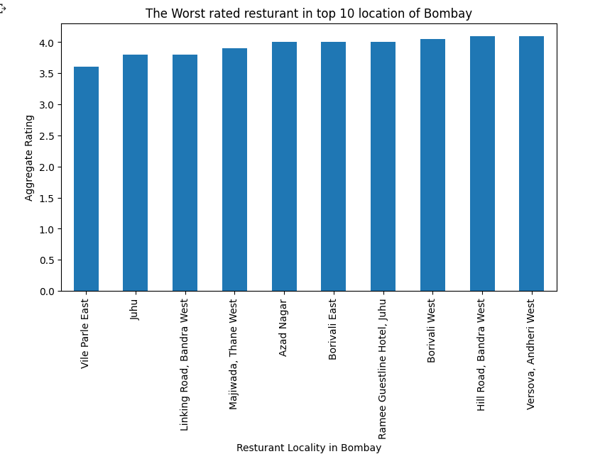

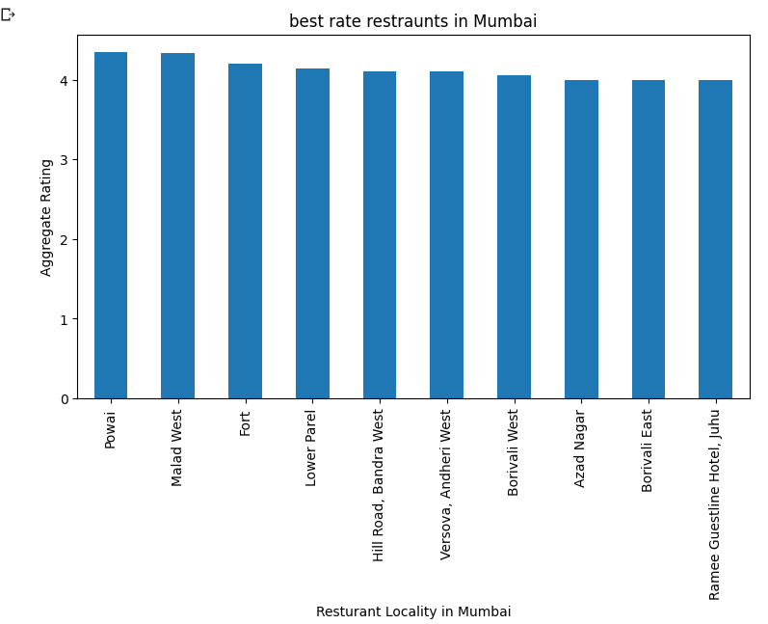

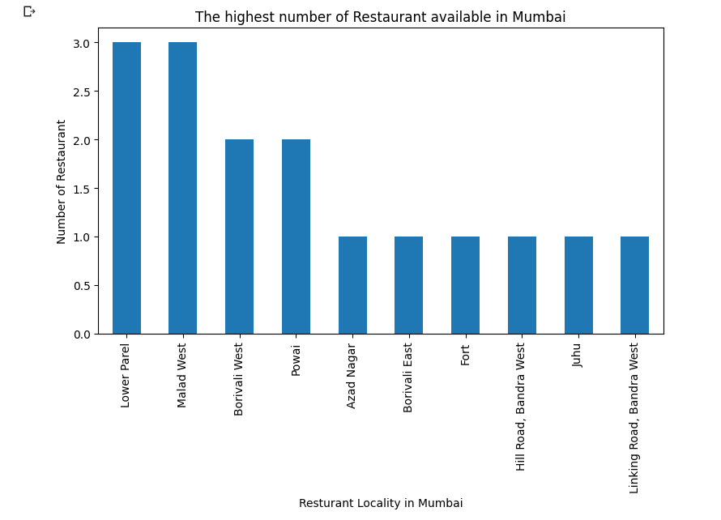

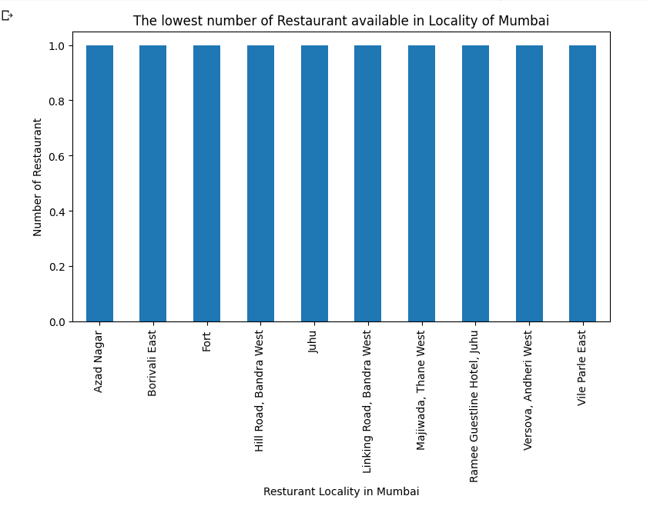

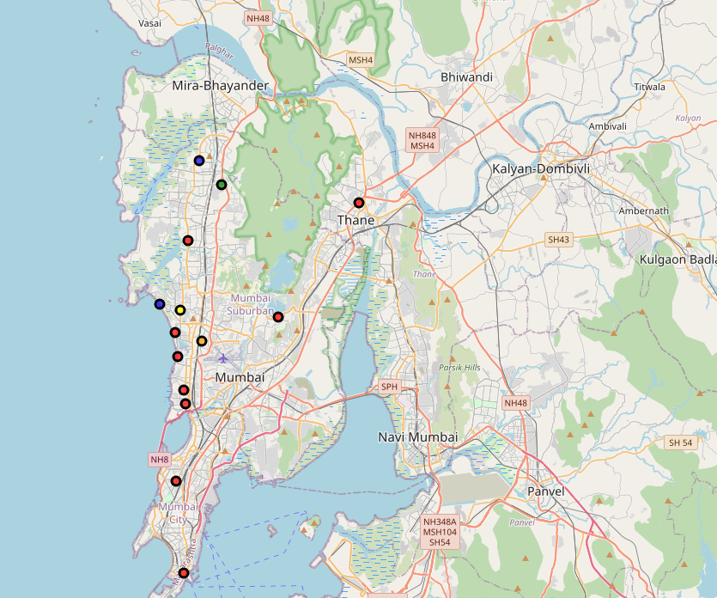

Cluster 1

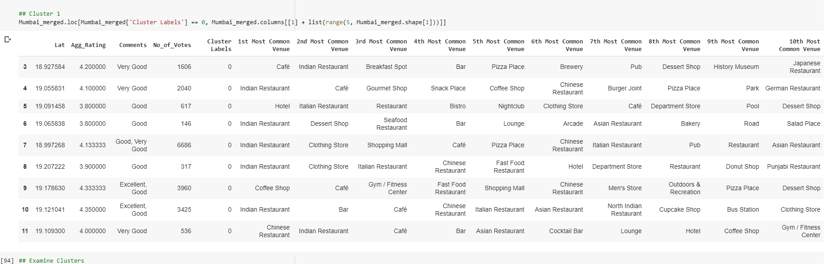

Cluster 2

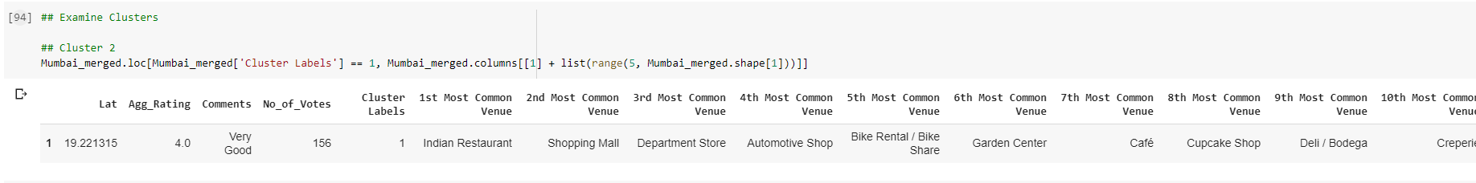

Cluster 3

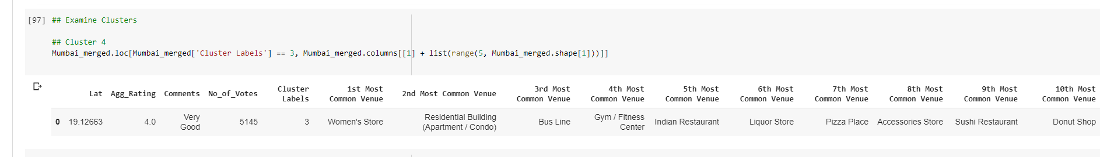

Conclusion :

1. Powai and Malad have best Restaurants
2. Vile Parle and Juhu have worst  Restaurants
3. Biggest number of Restaurants are in Lower Parel and Malad. This is the best place for foodie to live
4. Cluster 1 is most recommended for Indian Cuisine
5. Cluster 2 is good for Caffe
6. Cluster 5 is not recommended
7. Chinese restraint should choose between cluster 1 and 2